**E-Commerce Sales Analysis**

**Import Data:**

● Import “List of Orders.csv” into Power BI.

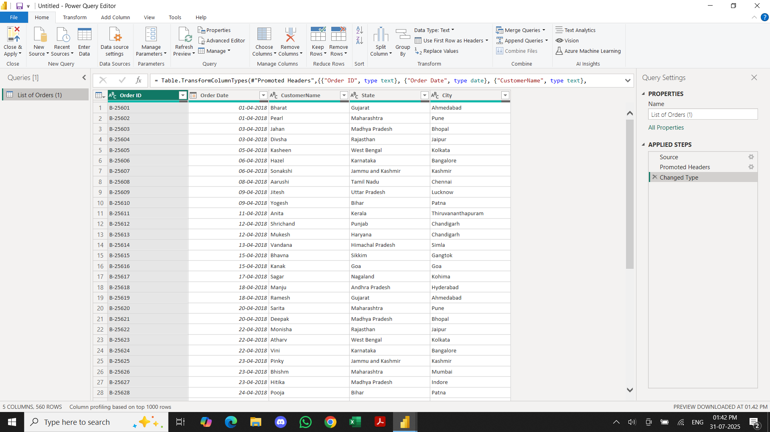

● Import “Order Details.csv” and “Sales target.csv” into Power Query Editor.

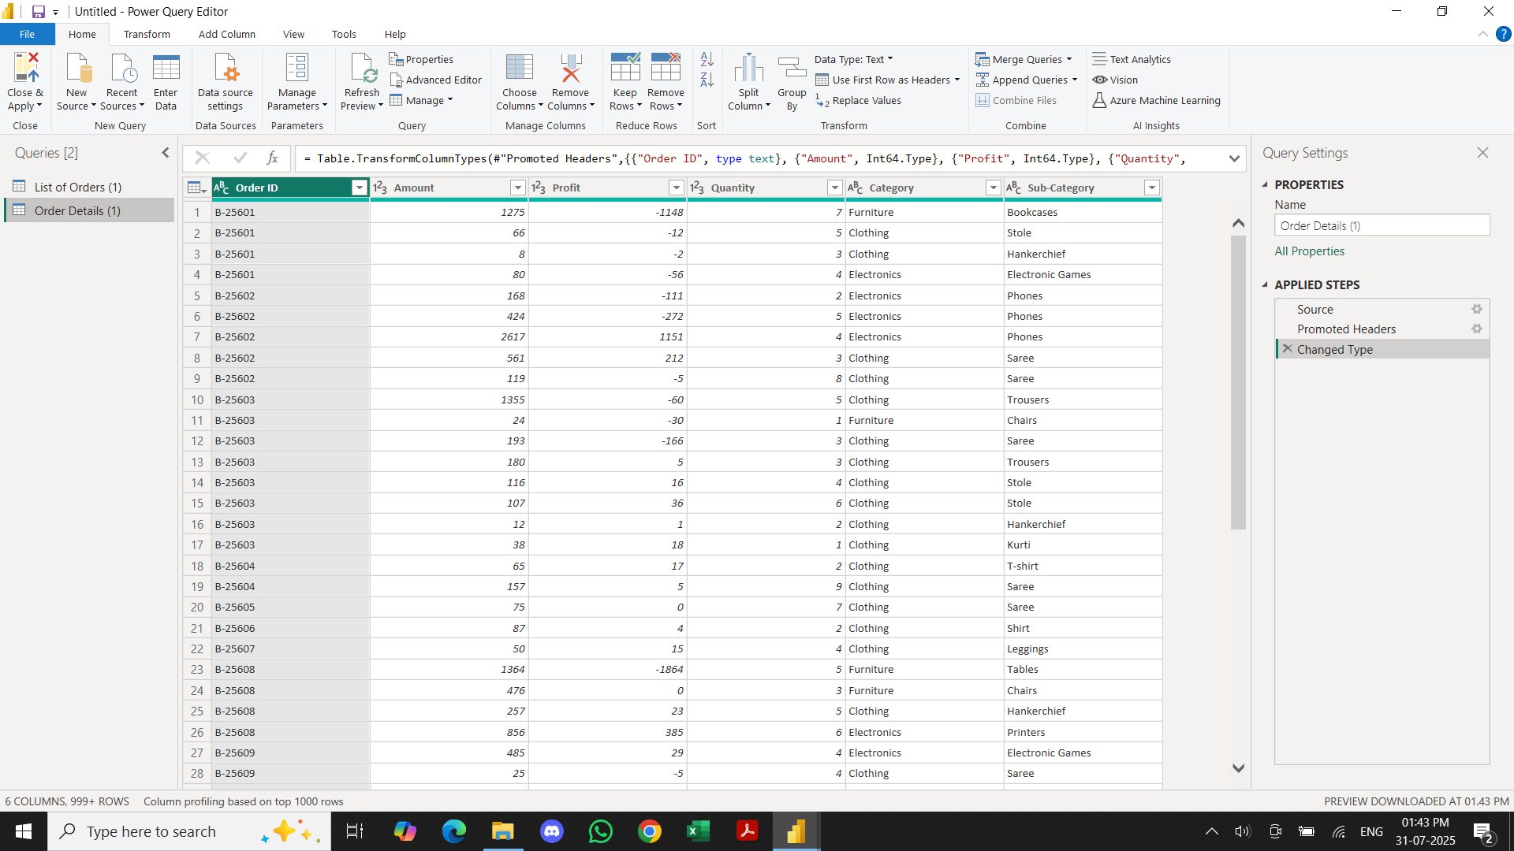

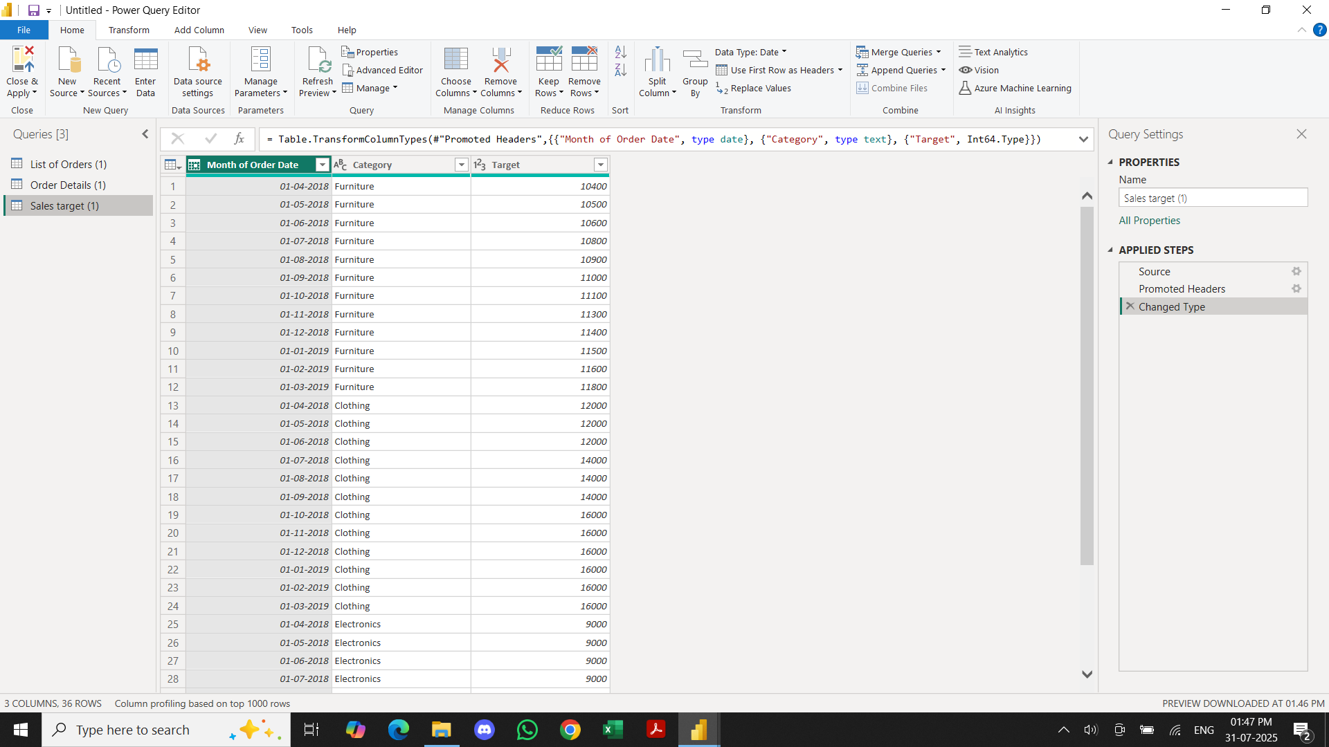

**Data Transformation:**

● Restrict the "List of Orders" table to only the first 500 rows.

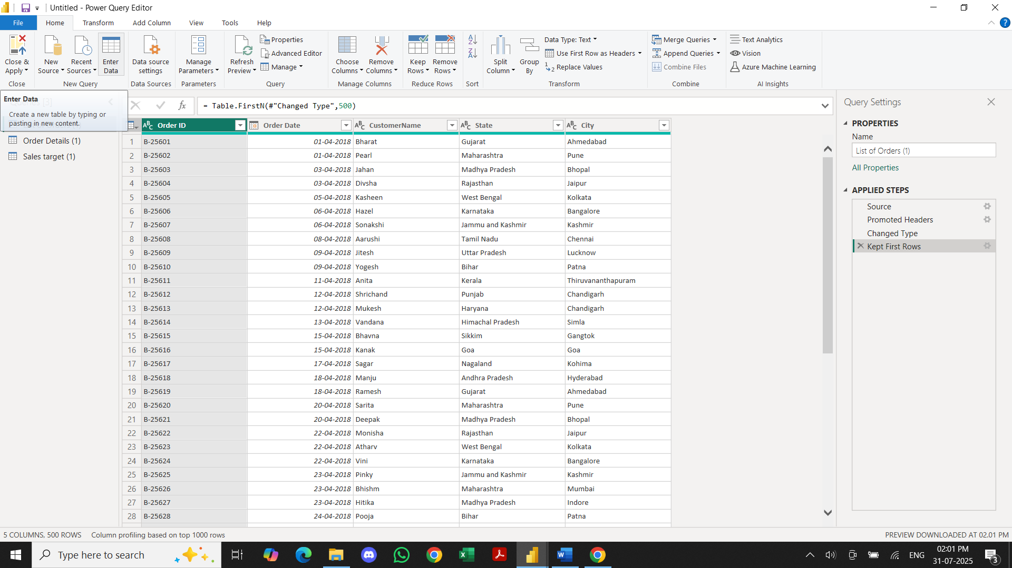

● Ensure the “Order Date” column in the “List of Orders” table is set to data type 'Date'.

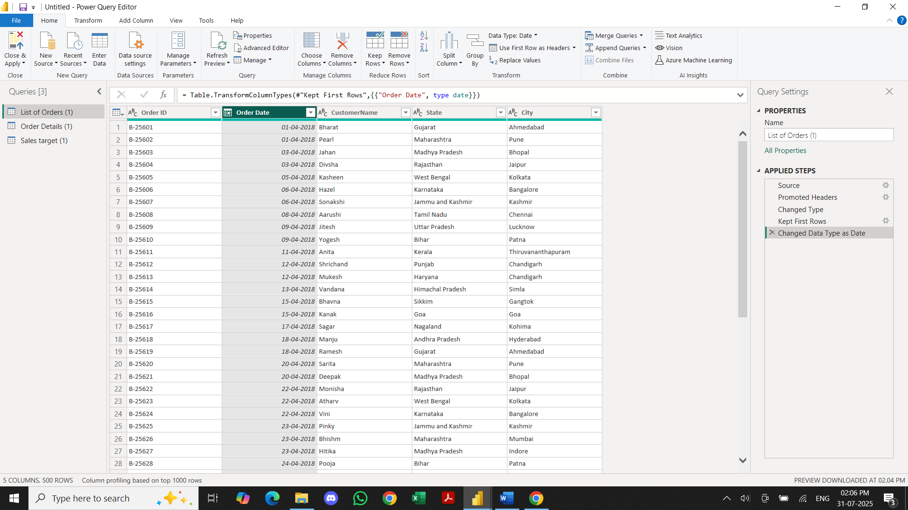

● Change the data type of “Amount” and “Target” columns to ‘Fixed Decimal Number’.

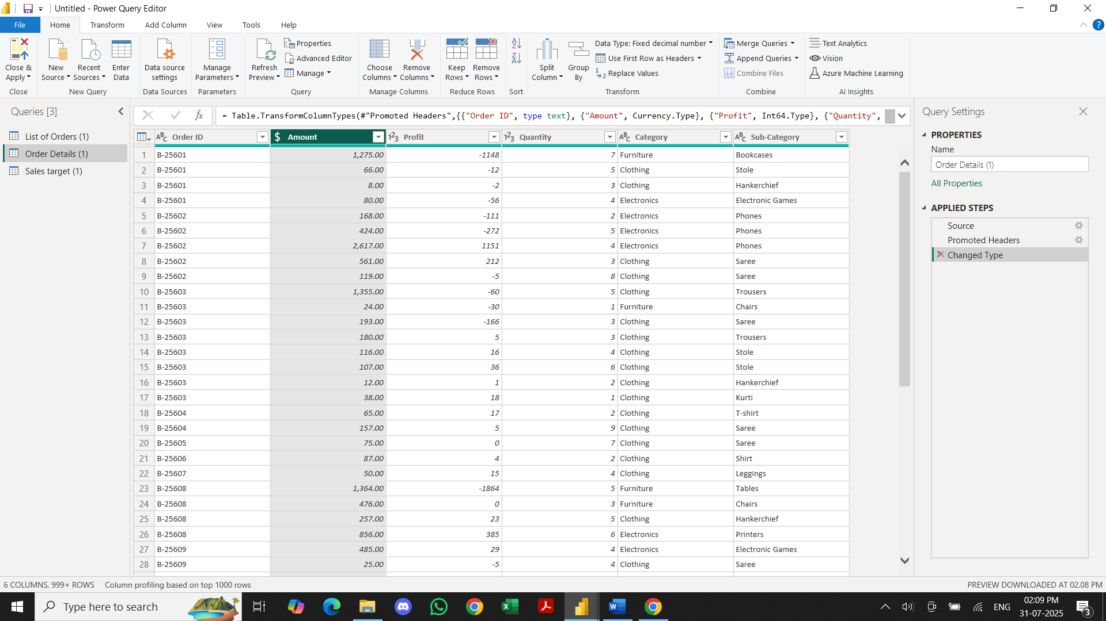

● Format the "Customer Name" column into proper case, ensuring consistent

capitalization for each word.

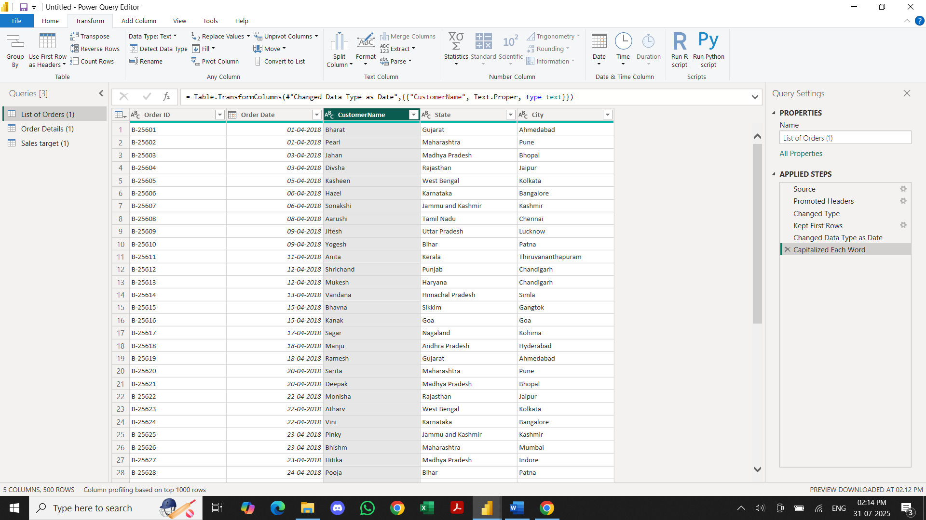

● Merge the "State" and "City" columns to create a new column named "Location" in

the format ‘City, State’.

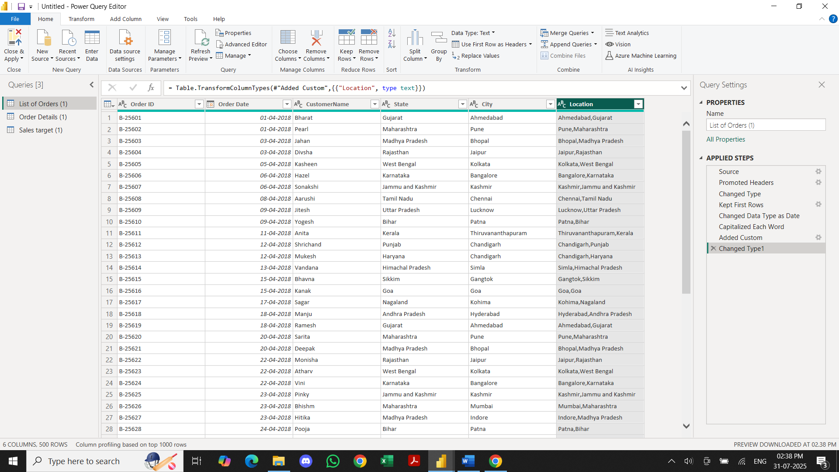

● Create a new custom column named "Profit Margin" as the percentage of "Profit"

divided by "Amount".

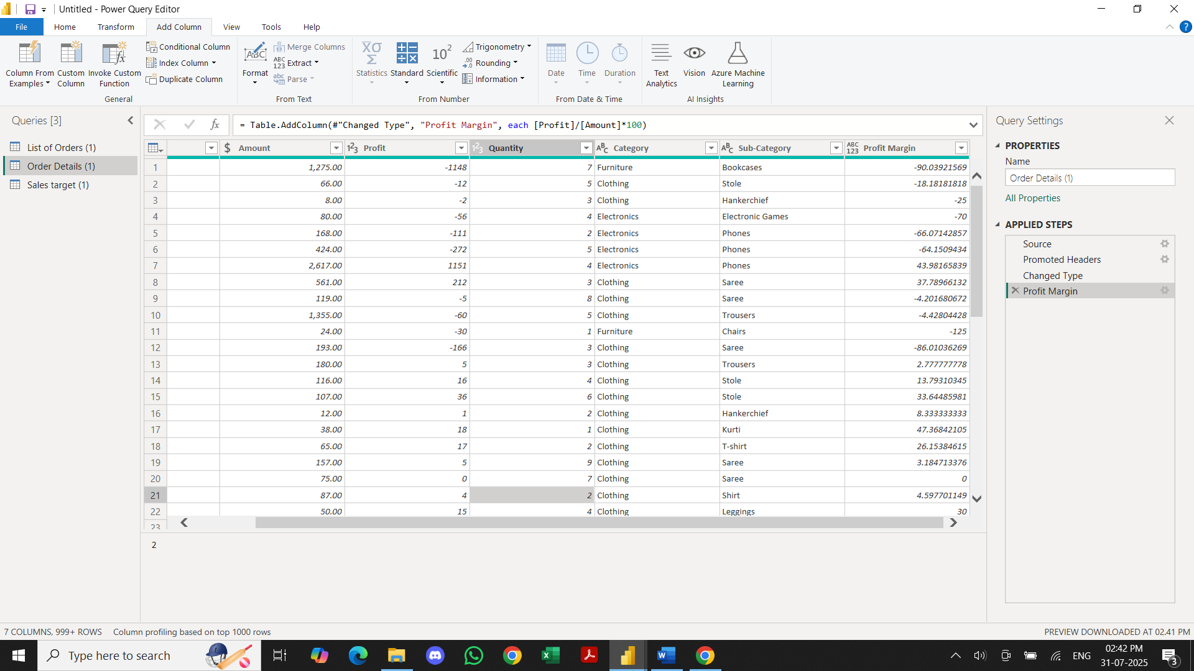

Add a new conditional column named "Profit Status" based on the values in the

"Profit" column.

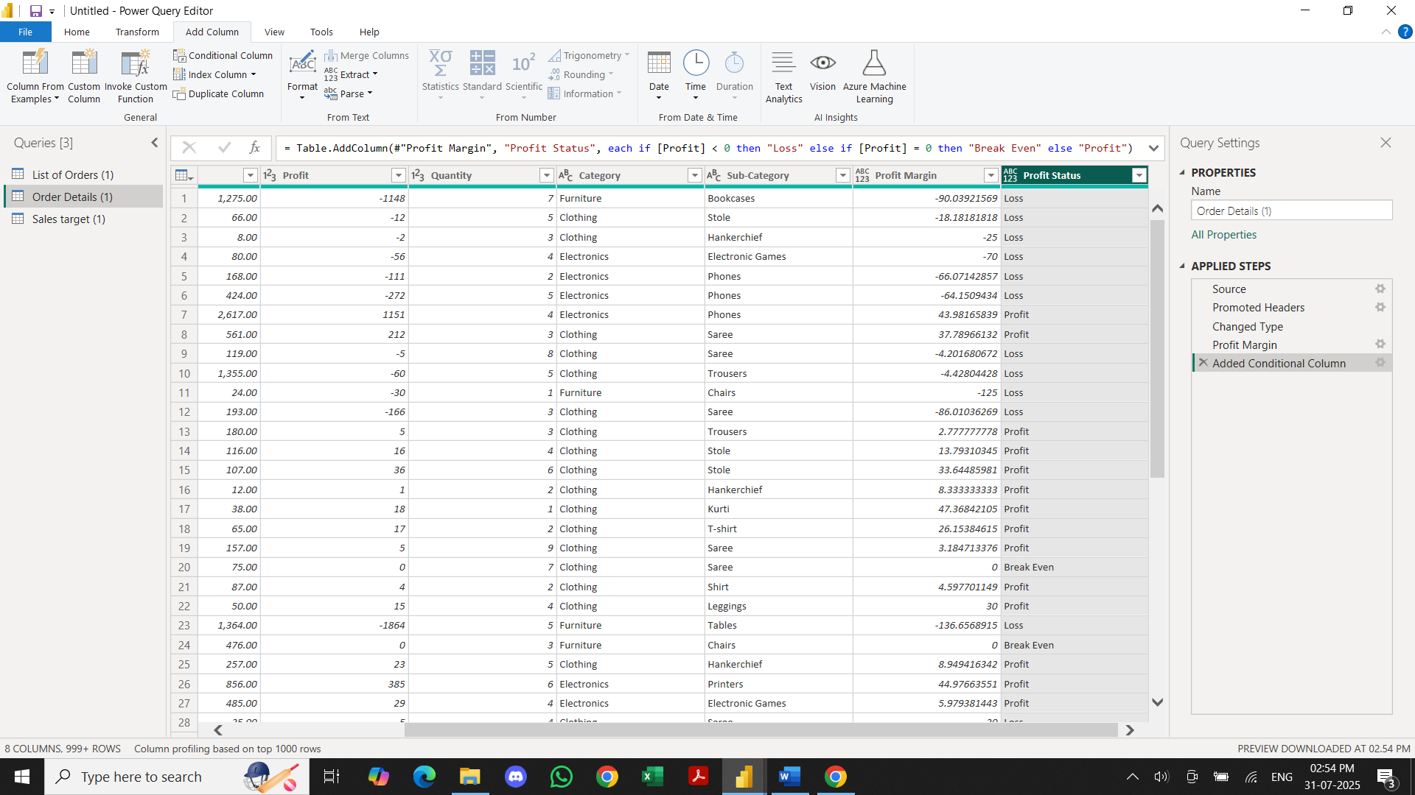

**Merging Data (Joins):**

● Merge the "List of Orders" and "Order Details" tables into a new single table named

"Orders Data" based on the "Order ID" relationship.

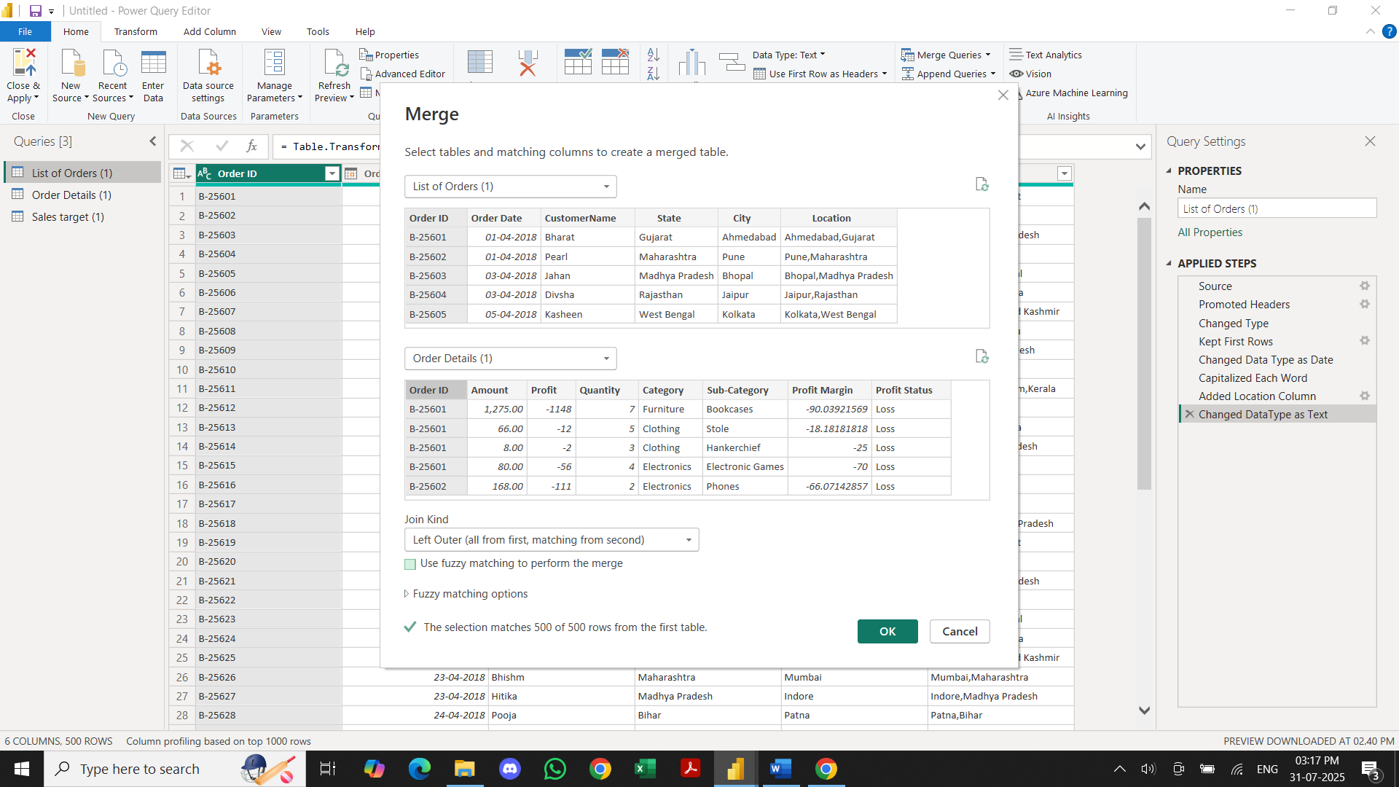

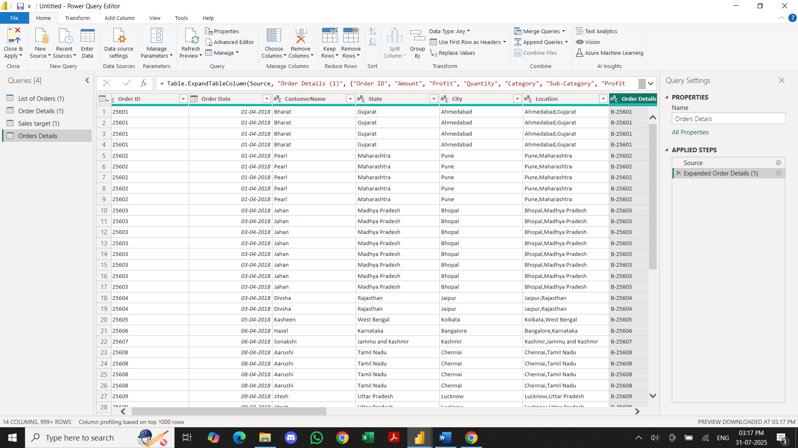

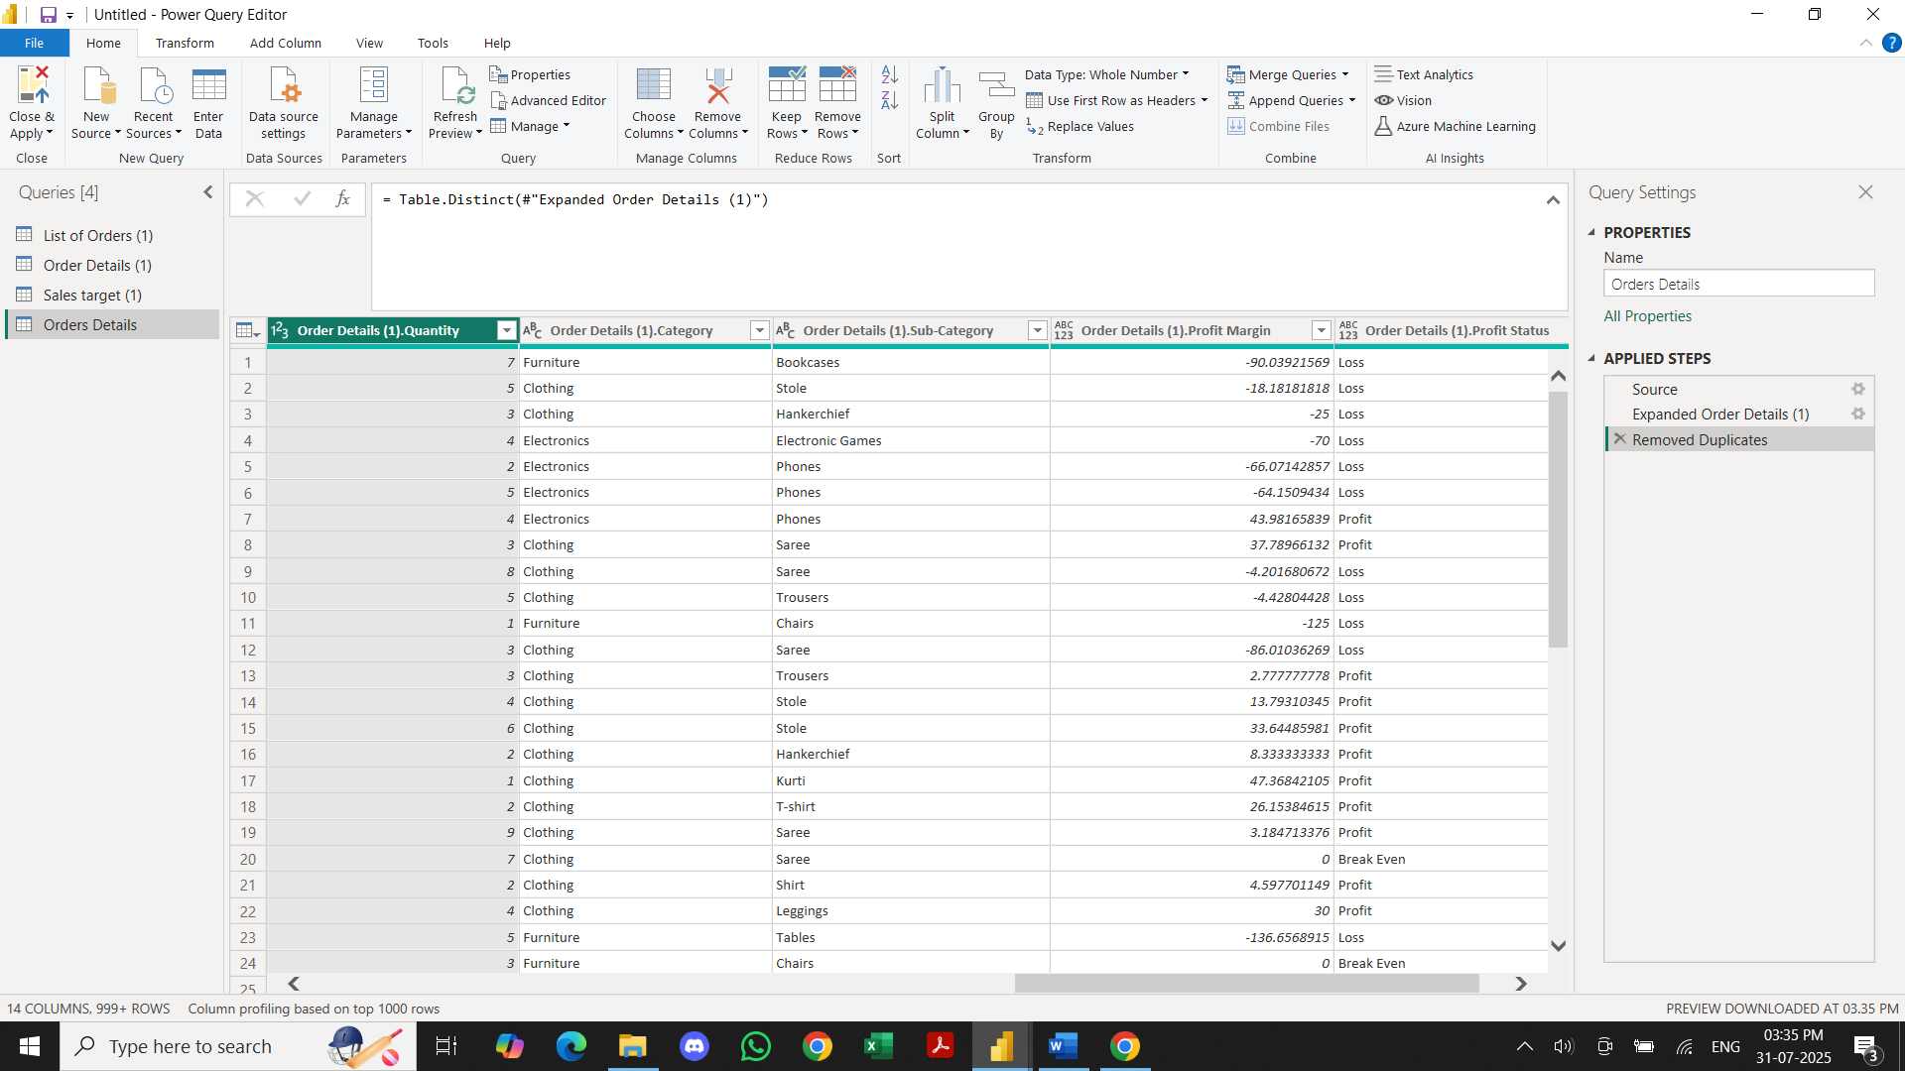

**Sorting and Filtering Data:**

◆ Sort the orders by Order Date in descending order to analyze recent trends.

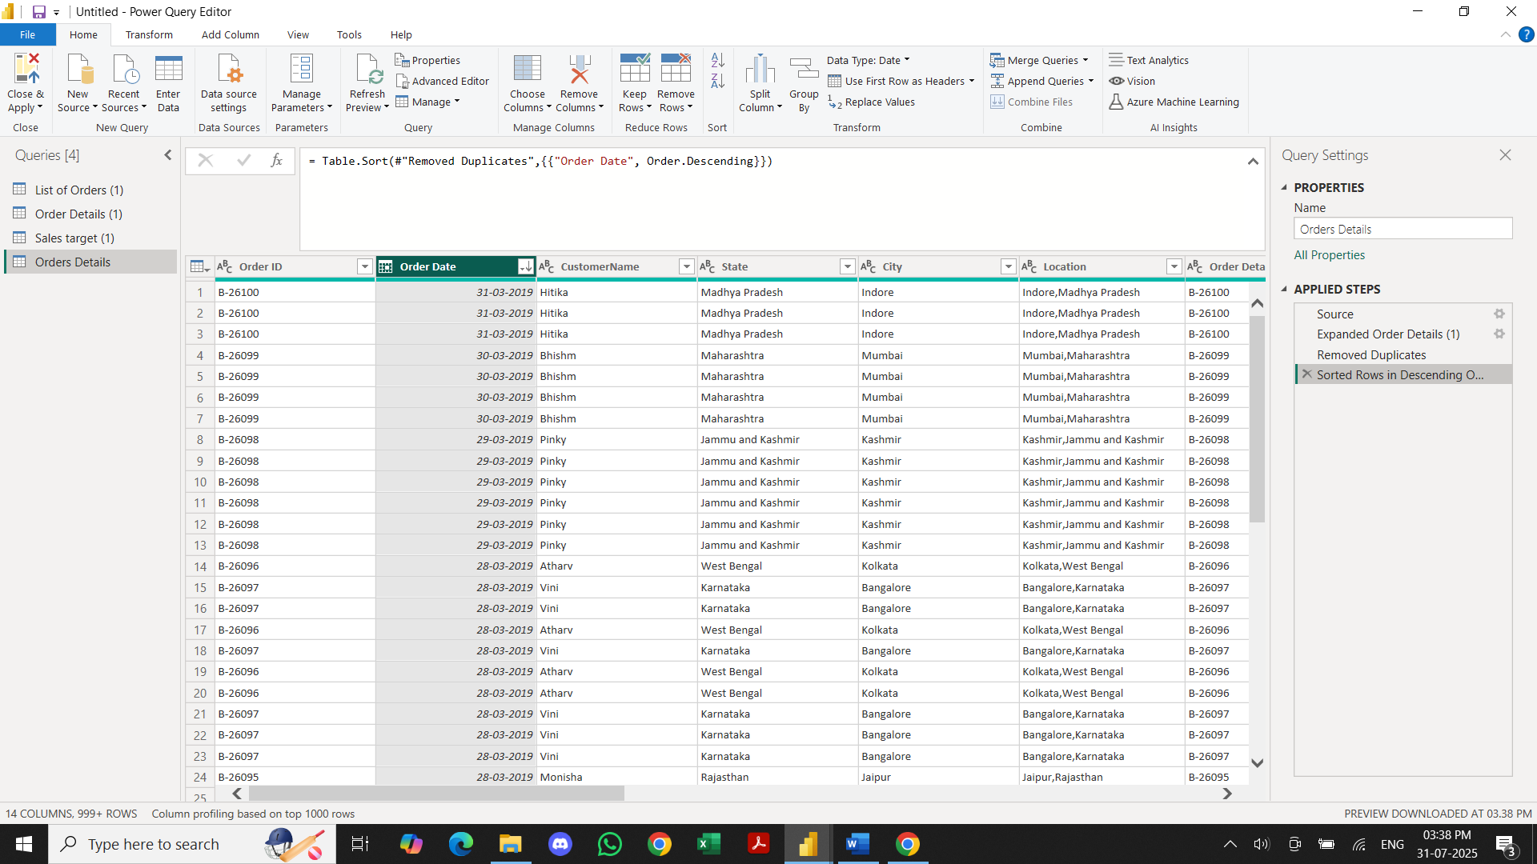

◆ Filter the orders to focus only on a specific state (e.g., Tamil Nadu) for

regional analysis.

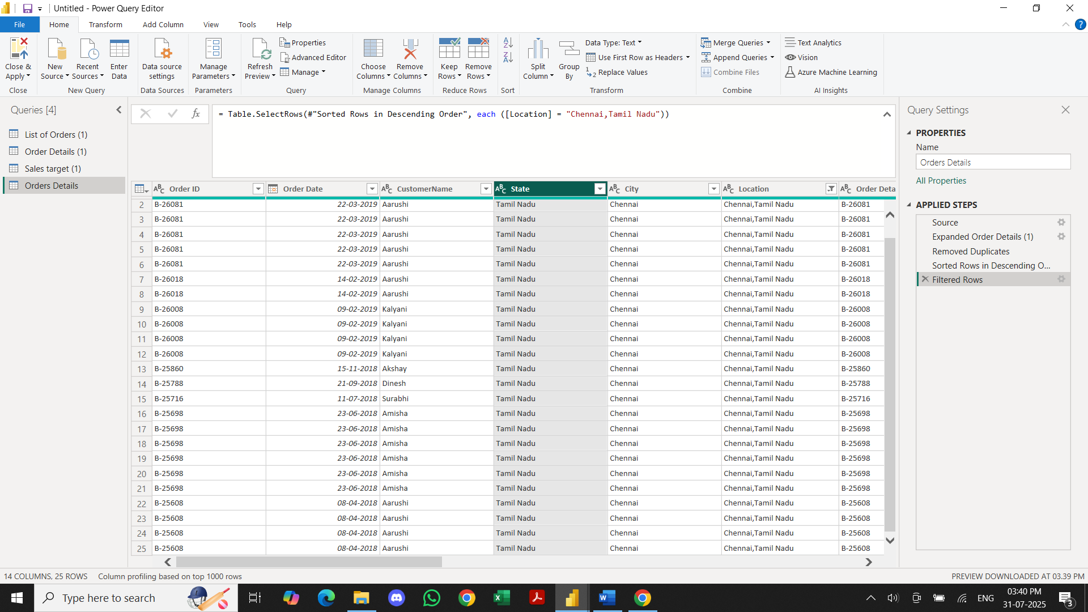

**Grouping and Aggregating Data:**

● Duplicate the “Order Details” table and calculate the count of each Order ID, average

profit by Category or total amount by Sub-Category.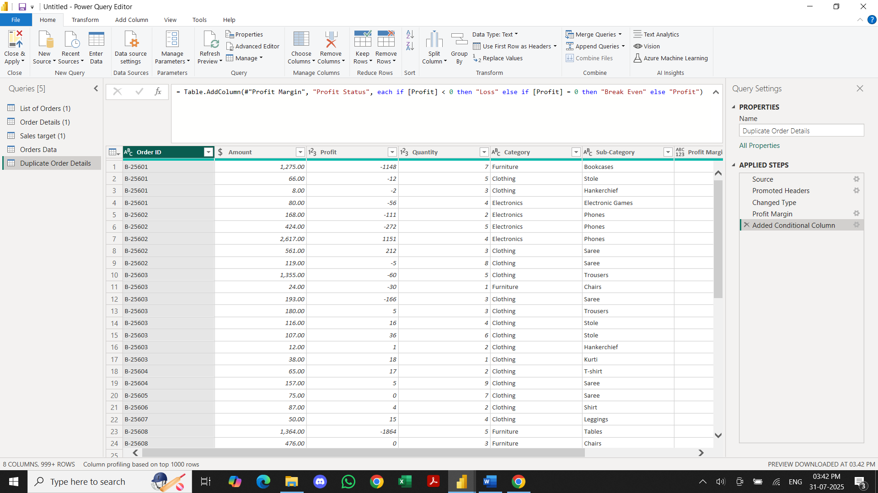

* COUNT OF ORDER ID:

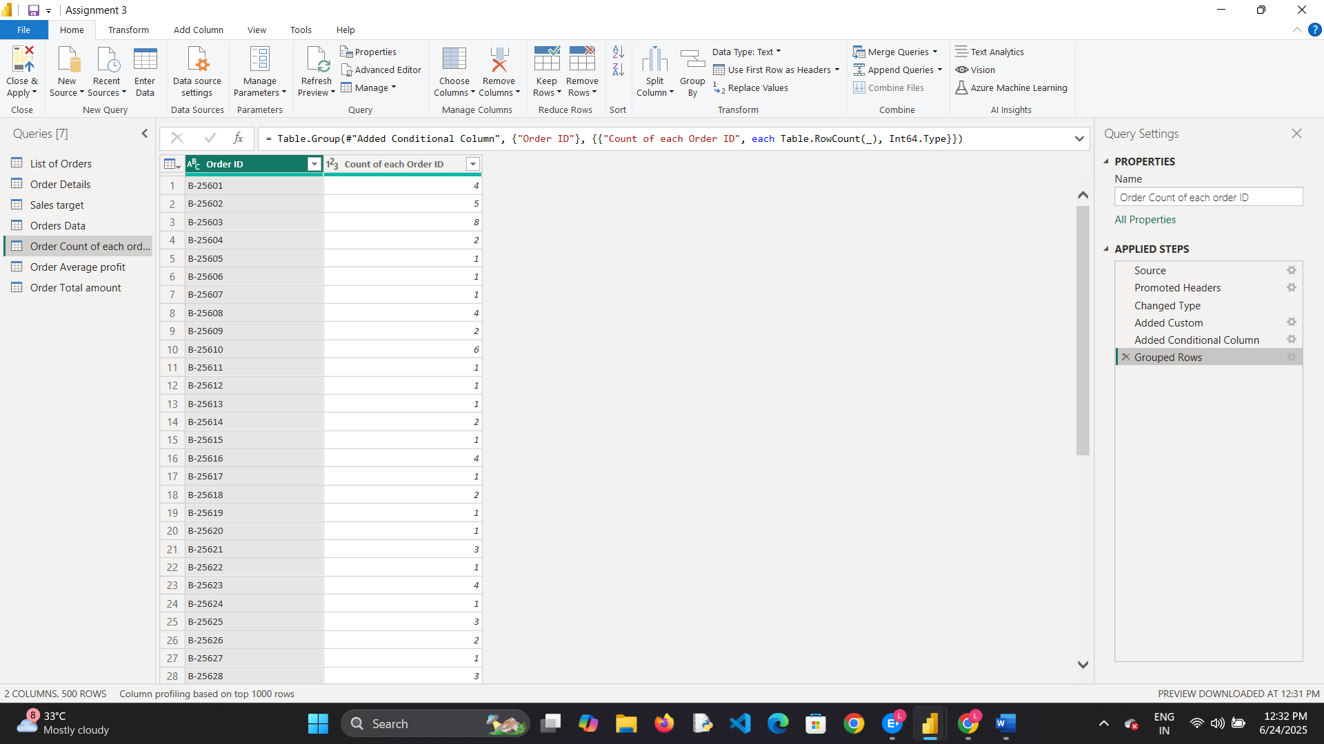

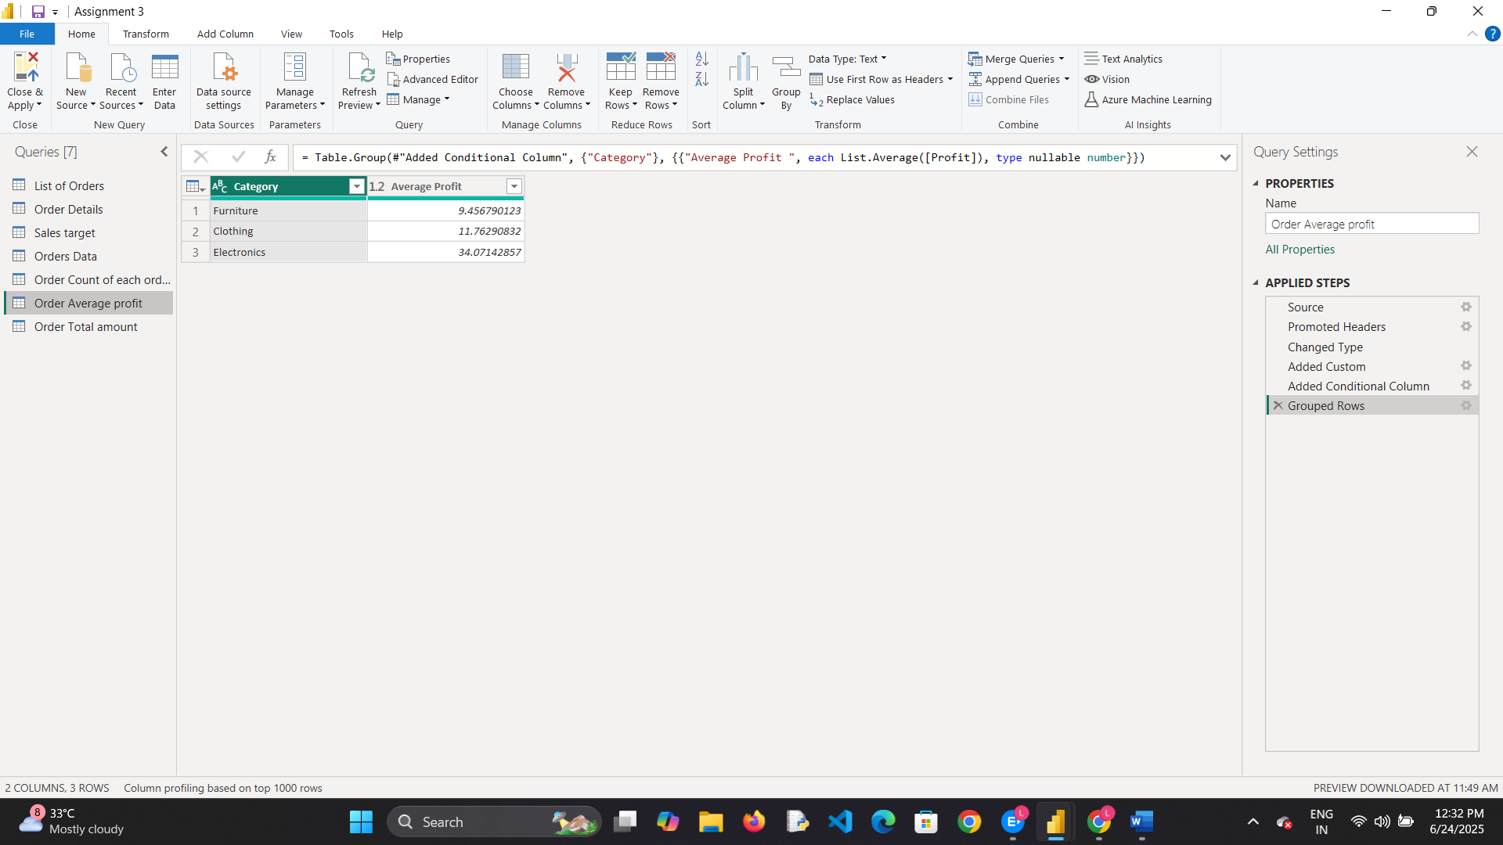

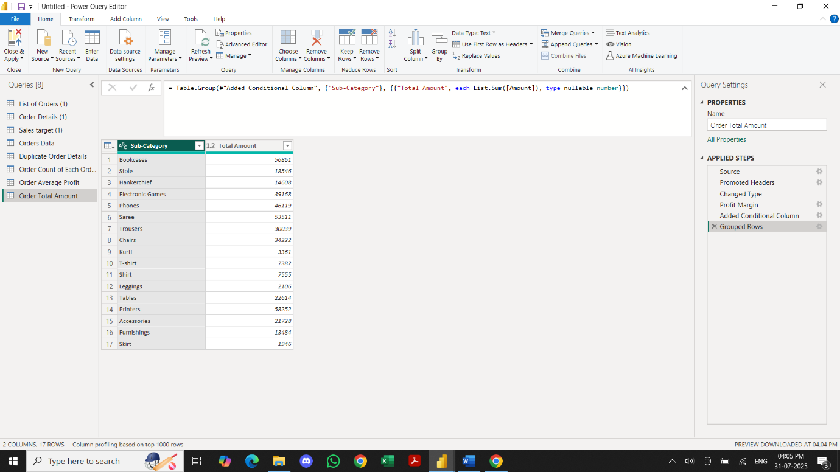

Duplicate the “Sales Target” table and aggregate the total target amount by Month of

Order Date.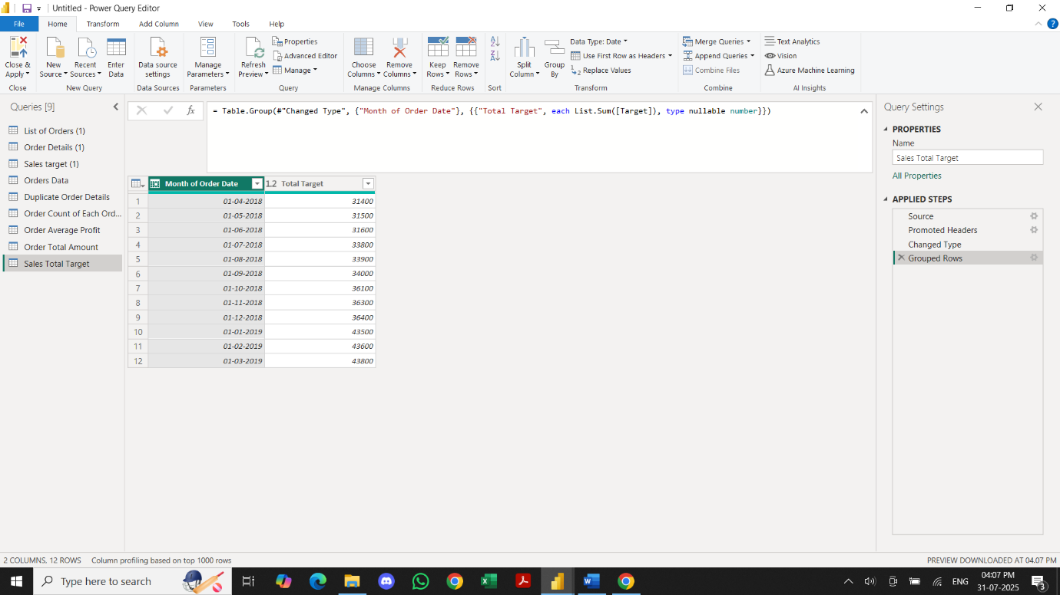

Data Modeling:

● Establish a relationship between the “List of Orders” and “Order Details” tables using

the ‘Order ID’ column.

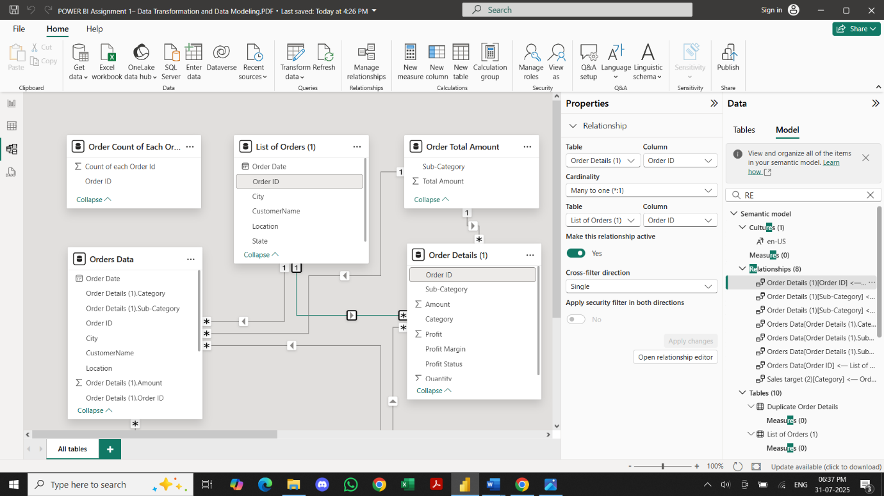

● Build a relationship between the “Order Details” and “Sales Target” tables based on

the ‘Category’ column. Click "Manage relationships" and ensure this relationship is

active.

